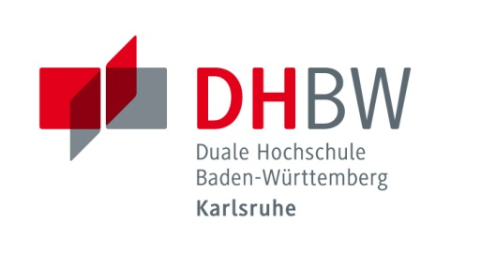
Duale Hochschule Baden-Württemberg Karlsruhe
Baden-Wuerttemberg Cooperative State University

Application for Students of Partner Institutions (Internship)

Personal Information
Last name |  | First name
Sex(M/F) |  | Date of birth
Place of birth |  | Email
Phone |  | Mobile phone
Country |  | City
Post code
Address

Language Skills
German language level | A1 A2 B1 B2 C1 C2
English language level^{[1]} | A1 A2 B1 B2 C1 C2

[1] According to CEF (A Common European Framework of Reference for Languages)
CEF
A1 Breakthrough
A2 Waystage
B1 Threshold
B2 Vantage
C1 Effective Operational Proficiency
C2 Mastery

University Information
Home University
Major
Which academic year (out of total)
Courses taken at home university to show your scientific qualification | 1. __________________________________  2. __________________________________  3. __________________________________  4. __________________________________  5. __________________________________  6. __________________________________  7. __________________________________  8. __________________________________  9. __________________________________

Duration of stay^{[2]} | From___/___/___ To ___/___/___ ___months
Accommodation in a student residence | Yes No
Participation in German course | Yes No
Person(s) to contact in case of emergency | Name:  Contact No.:
Preferences concerning the internship (branch, type of company, department)

[2]Format of date: DD/MM/YY

Detailed information about the reservation of a room in a student residence will be provided after receipt of your application.
I herewith acknowledge that the room reservation has to be confirmed within two weeks after receipt of the information. Without confirmation, the room reservation will be cancelled.

City, Date: ______________________________________________________
Signature of the student: _____________________________________________

This application form is valid only with the following data and signature:
International Coordinator at home university
Phone |  | Fax
Email
Signature (stamp) of the International Coordinator | I hereby confirm the data the student has given with this application form.
The following documents are enclosed (please mark):
Copy of my identity card (or passport)
Proof of health insurance
Enrollment certificate of home university
City, Date: __________________________________________________
Signature of the student: _______________________________________
Duale Hochschule Baden-Württemberg Karlsruhe
Baden-Wuerttemberg Cooperative State University
International Office
Erzbergerstr. 121
76133 Karlsruhe, Germany
Alexandra Braswell, Marina Weißenborn
Tel. 0049-721-9735-707/-729
InternationalOffice@dhbw-karlsruhe.de

