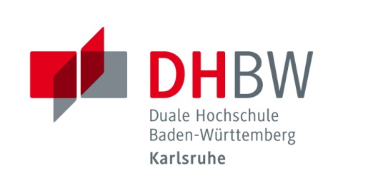
Duale Hochschule Baden-Württemberg Karlsruhe
Baden-Wuerttemberg Cooperative State University

Application for Students of Partner Institutions (Study)

Personal Information

Last name |  | First name
Sex(M/F) |  | Date of birth
Place of birth |  | Email
Phone |  | Mobile phone
Country |  | City
Post code
Address

Do you want to have a German buddy? | Yes No  If yes: female male male or female
I agree that the following contact details can be forwarded | Email  Mobile phone (e.g. for WhatsApp contact)  not necessary (I’m not interested in the buddy program)
Interests | Sports:____________________________________  Hiking  Cooking  Cultural activities (museum, theater, movies …)  Others:________________________________________

Language Skills (Common European Framework of Reference for Languages)

German language level* | A1 A2 B1 B2 C1 C2  none
English language level* | A1 A2 B1 B2 C1 C2
Other language and level | _________________________________________

*Please attach a language certificate if available.

University Information

Home University
Major
Which academic year (out of total)
Courses to be taken at DHBW | 1. __________________________________  2. __________________________________  3. __________________________________  4. __________________________________  5. __________________________________  6. __________________________________  7. __________________________________  8. __________________________________  9. __________________________________

Duration of stay^{[2]} | From___/___/___ To ___/___/___ ___months
Accommodation in a student residence | Yes No
Participation in preparatory German course for beginners | Yes No
Person to contact in case of emergency | Name:  Contact No.:
[2]Format of date: DD/MM/YY

Detailed information about the reservation of a room in a student residence will be provided after receipt of your application.
I herewith acknowledge that the room reservation has to be confirmed within two weeks after receipt of the information. Without confirmation, the room reservation will be cancelled.

City, Date: ______________________________________________________
Signature of the student: _______________________________________________
This application form is valid only with the following data and signature:
International Coordinator at home university
Phone |  | Fax
Email
Signature (stamp) of the International Coordinator | I hereby confirm the data the student has given with this application form.

To be enclosed:
=> Copy of identity card (or passport) and proof of health insurance
=> Enrollment certificate of home university

City, Date: __________________________________________________

Signature of the student: _______________________________________

Duale Hochschule Baden-Württemberg Karlsruhe
Baden-Wuerttemberg Cooperative State University
International Office
Erzbergerstr. 121
76133 Karlsruhe, Germany
Alexandra Braswell, Marina Weißenborn
Tel. 0049-721-9735-707/-729
InternationalOffice@dhbw-karlsruhe.de

